Sai Kankanalapati-Resume

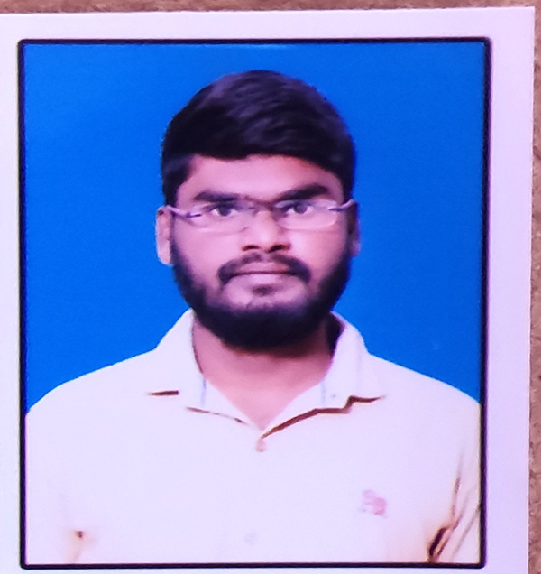
SAI KANKANALAPATI
Email: kankanalapati28@gmail.com Mobile: +91 -9100809395
Career Objective:

Seeking for a challenging career in an industry where my skills can be efficiently utilized for the growth of the organization as well as my individual development.

Academic Qualifications:

- Graduation (B. Tech) in Electronics and Communication engineering (ECE) at chirala engineering college with an aggregate of 60.0% in the year 2021.
- Intermediate from Sri Harshini junior College with an aggregate of 79.3% in the year 2015.

- SSC from Z.P.H School with an aggregate of 72% in the year 2012.

Technical Skills:

➢ Products and Tools | : Visual Studio 2017
➢ Programming Languages | : | C#
➢ Database Languages | : | TSQL
➢ Markup Languages | : | HTML
➢ Data Base | : | SQL Server 2008
➢ Web Technologies | : | ASP.Net basics

Training Details:

I have pursuing training on .NET & SQL from Palle Technologies Bangalore.

Training modules Include:

- SQL SERVER
- C#
- ASP.Net Basics
- HTML
- CSS
- Java Script

Academic Project Details:

Project: Voice controlled robotic vehicle with obstacle detection and collision avoidance

Description: The project is design to build an obstacle detection and collision avoiding robotic vehicle using ultrasonic sensors for its moment. An Arduino is used to achieve the desired operation. A robot is a machine that can perform task automatically or with guidance. This robotic vehicle is build using an Arduino. An ultrasonic sensor is used to detect any obstacle a head of it and sends a command to the microcontroller.

Personal Details:

Fathers Name : Srinu

Address : Bobbepalli, martur(mandal), prakasam(district)-523301, AP.

Date of Birth : 6th July 1997

I hereby declare that the information furnished above is true to the best of my knowledge and belief.

Place: Bangalore

Date: SAI KANKANALAPATI

